# INTRODUCTION

This document describes an open-source Python 2.7 software package, PStreams, for processing streams of data.

### Goals of the package

1. Enable programmers to continue to use familiar data structures such as Python lists, NumPy arrays and Pandas frames, and then transform their programs to operate on data streams. Programmers first focus on the logic of their code using fixed-size lists and arrays, and later extend the logic to streaming systems in which new data arrives in streams over time.
2. Enable programmers to develop and test programs in a single process and later map software components of the program to hardware components in a distributed system. These hardware components include: single-board computers such as the Raspberry Pi, cloud services, and processing elements in the network connecting sensors to the cloud. The goal, again, is separation of concerns: first develop logic and later distribute it.
3. Separate concerns of processing logic from system control. Control of a streaming application addresses issues such as how frequently should a function be executed whereas logic deals with the definition of the function itself. Control in streaming deals with features such as clocks and time stamping, communication protocols, and archival storage for streams.
4. Extend Python science and data-mining packages such as NumPy, SciPy, Pandas and SciKit-Learn, which were not necessarily intended for streaming applications, to streaming.

This document describes a Python streaming package. It is not an exposition on stream processing, distributed computing, or Python. This introductory chapter does not discuss performance issues, incremental computation on streams, distributed computing of streams, or science and data-mining packages. Of the three goals listed above, this section deals with the first: converting functions that operate on Python lists to functions that operate on streams.

### Streams

A *stream* is a sequence of values. Values in a stream are called *messages*. The only way in which a stream can be modified is that messages can be appended to the end of a stream. A message in a stream cannot be modified, and messages cannot be reordered. An example of a stream is a sequence of measurements made by a sensor; as time progresses the sensor may make more measurements and send messages containing measured values along the stream. However, the sensor cannot retract or modify messages.

The messages in a stream are arbitrary objects; messages in a stream need not belong to a special class. Some messages in a stream may have timestamps and locations while other messages may not.

### From Lists to Streams

Here, we consider streams in which the value of a stream, at any point in time, is a list of Python objects (messages). Later, we describe streams with values that are NumPy arrays.

If at some point, the value of a stream is the list [3, 5], then from that point onwards, the value of that stream will be a list that begins with [3, 5]. For example, at a later point in time the stream can be [3, 5], or [3, 5, 2], or [3, 5, 2, 6], but not [3, 4] or [1, 5, 2].

#### Operations on lists: functions from a list to a list

Given a function *f_list* that has a list as input and returns a list, we define a function *f_stream* that has a stream as input and returns a stream, and that operates similarly to *f_list*, as follows:

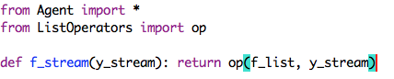

*f_stream*(*y_stream*) is a stream that is automatically updated when messages are appended to *y_stream*. If the value of *y_stre*am is a list, *y_list*, at some point t in time, then the value of *f_stream*(*y_stream*) will become *f_list*(*y_list*).

##### Example of op: operations on lists

We want to write a function that takes a stream of integers as input and produces a stream as output where the elements of the output stream are squares of odd (i.e. not multiples of 2) elements of the input stream. We first write the same function except that it operates on lists. Then, we use the function on lists to create a function on streams.

##### First step: create a function from a list to a list



Let’s check the function for a simple input: *f_list*([7, 4, 9, 12]) = [49, 81]; so the odd numbers 7 and 9 were squared.

##### Second step: define function from a stream to a stream

Macintosh HD:Users:mani:Desktop:Screen Shot 2015-02-16 at 2.00.17 PM.png

Example:

Here is an example of using *f_stream*:

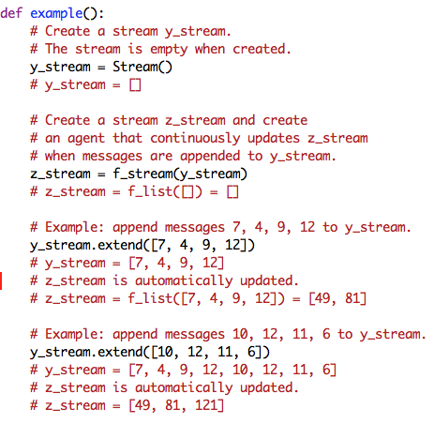

**Restriction on list function f_list**

The function *f_list* must return the same value regardless of whether the list is processed element by element of in groups (and so *f_list* must be prefix closed): for any list x and any nonnegative integer n where n < len(x):

$f\left(x\right)= f\left(x\left[:n\right]\right).extend(f(x\left[n:\right])$

An example of a function that we do *not* allow is:

Macintosh HD:Users:mani:Desktop:Screen Shot 2015-02-16 at 3.28.50 PM.png

This is because if x = [1, 2, 3], then h(x[:2]) = [1, 2]) and h(x[2:]) = [3], but h(x) = [0] whereas if h were prefix-closed, the value of h(x) would be [1, 2, 3].

##### Composition of functions on streams

Composing operations on streams, just as we do on lists, is convenient. Later, you will see examples of applications constructed as compositions of functions on streams. Here is an example in which *g* and *f* are functions from a stream to a stream; so, *h* is also a function from a stream to a stream.

Macintosh HD:Users:mani:Desktop:Screen Shot 2015-02-16 at 3.35.50 PM.png

The way in which functions on streams were obtained from functions on lists is shown diagrammatically in the following figure.

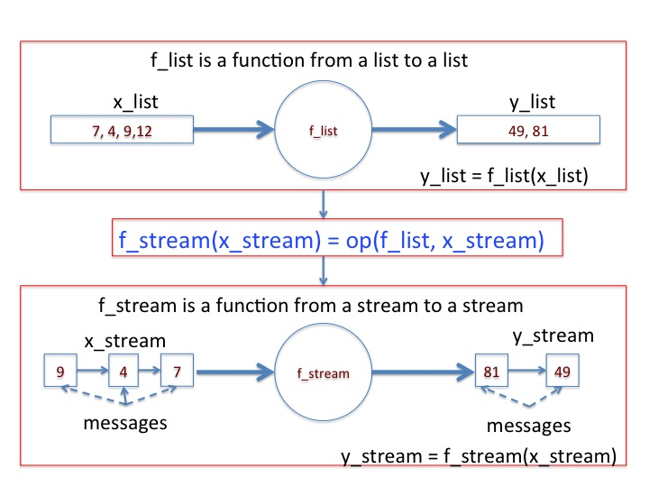

**Figure: Relationship between functions on lists to functions on streams**

Just as you can use a function from a list to a list to obtain a function from a stream to a stream, you can use a function from a list of multiple lists to a list (merge), or from a list to a list of multiple lists (split), or from a list of multiple lists to a list of multiple lists (many_to_many) to get the corresponding functions on streams. These functional forms are shown in the next diagram.

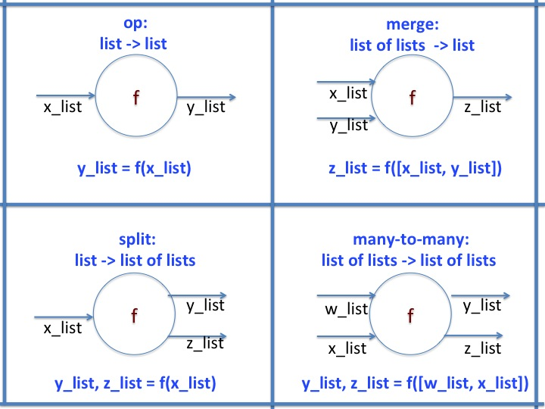

## Merge: Functions from multiple lists to a single list

Given a function f that has a list of lists as input and returns a list, we define a function F that has a list of streams as input and returns a stream, as follows:

from Agent import *

from ListOperators import merge

def F(list_of_streams): return merge(f, list_of_streams)

We use *merge* rather than *op* because op is an operator – a function from a list to a list – whereas here f is a function that merges multiple lists into a single list.

F(list_of_streams) is a stream that is updated when messages are appended to any stream in list_of_streams. If the value of list_of_streams is x at some point in time, then the value of F(list_of_streams) will become f(x) at that point or later.

**Example of *merge***

We want to write a function that takes multiple streams as input and produces a single stream as output where the output stream sums corresponding values of the input streams. We first write a function f on lists and then use list-function f to create a function F on streams. So, we write a function f that takes multiple lists as input and produces a single list as output where the output list sums corresponding values of the input lists.

def f(list_of_lists): return map(sum, zip(*list_of_lists))

Next we use list-function f to create a function F on streams:

from Agent import *

from ListOperators import merge

def F(list_of_streams): return merge(f, list_of_streams)

Next we create streams and use function F.

# Create streams x_stream and y_stream. Their initial values are empty lists.

x_stream = Stream()

y_stream = Stream()

# Create stream z_stream and an agent that populates z_stream.

z_stream = F([x_stream, y_stream])

# Values of x_stream, y_stream, and z_stream are empty lists.

# Since f([[ ], [ ]]) = [ ], the value of z_stream is [ ]

Next let us append messages to x_stream.

x_stream.extend([3, 5])

# Values of x_stream and y_stream are [3, 5] and [ ] respectively.

# Since f([[3, 5], [5]]) = [ ], the value of z_stream is [ ]

Next let us append messages to y_stream:

y_stream.extend([2, 4, 5])

# Values of x_stream and y_stream are [3, 5] and [2, 4, 5] respectively.

# z_stream will become f([[3, 5], [2, 4, 5]]) = [5, 9]

Next let us append more messages to x_stream:

x_stream.extend([6, 7, 8])

# Values of x_stream and y_stream are [3, 5, 6, 7, 8] and [2, 4, 5] respectively.

# Value of z_stream will become f([[3, 5, 6, 7, 8], [2, 4, 5]]) = [5, 9, 11]

**Restriction on merge function f**

The restriction is an extension to the one given earlier for operations on single lists.

for all lists x, y, z,… and for all n where 0 <= n < min(len(x), len(y), len(z), …)

f(x,y, z,…) = f(x[:n], y[:n], z[n:],.. ).extend(f(x[n:], y[n:], z[n:],..)

This restriction allows agents to process input lists incrementally, as data arrives, since data that arrives later cannot violate earlier output.

## Split: Functions from a single list to multiple lists

Given a function f that has a list as input and returns a list of *two* lists, we define a function F that has a list of streams as input and returns a list of streams, as follows:

from Agent import *

from ListOperators import split

def F(x_stream): return split(f, x_stream)

To split a stream into n streams, where n is not 2, specify the number of outgoing streams as in the following example which splits x_stream into 3 streams:

def F(x_stream): return split(f, x_stream, num_out_streams=3)

We use *split* rather than *op* or *merge* because x_stream is split into multiple output streams.

F(x_stream) is a list of streams where streams in the list are updated when messages are appended to the stream x_stream. If the value of x_stream is x_list at some point in time then the value of F(x_stream) will become f(x_list).

**Example of *split***

We want to write a function that takes a single stream as input and produces two streams as output. The values on the first output stream has the even numbers in the input stream and the second output stream has the odd numbers. We first write a function f that takes a single list as input and produces two lists as output. The values on the first output list has the even numbers in the input list and the second output list has the odd numbers. We then use list-function f to create a function F that operates on streams.

def f(x_list):

return (filter(lambda n: n%2 == 0, x_list), \

filter(lambda n: n%2 != 0, x_list))

Now, let’s extend function f from lists to streams

from Agent import *

from ListOperators import split

def F(x_stream): return split(f, x_stream)

Next we create streams and use function F.

# Create a stream x_stream. Its initial value is the empty list.

x_stream = Stream()

# Create streams even_stream and odd_stream and

# create an agent that populates these streams.

even_stream, odd_stream = F(x_stream)

Next, let us append messages to x_stream.

x_stream.extend([0, 3, 5, 4])

# Value of x_stream = [0, 3, 5, 4]

# The value of even_stream will become [0, 4]

# The value of odd_stream will become [3, 5]

Next, let us append more messages to x_stream.

x_stream.extend([0, 4, 1, 6)

# Value of x_stream = [0, 3, 5, 4, 0, 4, 1, 6]

# The value of even_stream will become [0, 4, 0, 4, 6]

# The value of odd_stream will become [3, 5, 1]

**Example: *split* when the number of output streams is not 2**

Consider the following function from a list to a tuple of three lists:

def f(x_list):

return (filter(lambda n: n%2 == 0, x_list), \

filter(lambda n: n%3 == 0, x_list), \

filter(lambda n: n%5 == 0, x_list))

Now, let’s extend function f from lists to streams

def F(x_stream): return split(f, x_stream, 3)

You can now use function F in the usual way, as for example:

x_stream = Stream()

twos_stream, threes_stream, fives_stream = F(x_stream)

The restriction on list functions used for *split* is the same as that for *op*.

## many-to-many: functions from multiple lists to multiple lists

Given a function f that has a list of lists as input and returns a list of lists, we define a function F that has a list of streams as input and returns a list of *two* streams, as follows:

from Agent import *

from ListOperators import many_to_many

def F(list_of_streams): return many_to_many(f, list_of_streams)

As with *split*, specify the number of output streams (num_output_streams) if f returns a list of n lists where n is not 2. For example if f returns a list of 3 lists:

many_to_many(f, list_of_streams, num_out_streams=3)

We use *many_to_many* rather than *op*, *merge*, or *split* because here f is a function from a list of lists to a list of lists.

F(list_of_streams) is a list of streams where streams in this list are updated when messages are appended to any stream in list_of_streams. If the value of list_of_streams is x at some point in time then the value of F(list_of_streams) will become f(x).

**Example of many_to_many**

We want to write a function that takes multiple streams as input and produces two output streams. The values in the first output stream are the even values in the sum of the values of the input stream, and the second output stream contains the odd values. We first write a function f that takes multiple lists as input and produces two output lists where the values in the first output list are the even values in the sum of the values of the input list, and the second output list contains the odd values. Then we use list-function f to create a function F on streams.

def f(list_of_lists):

r = map(sum, zip(*list_of_lists))

return (filter(lambda v: v % 2 == 0, r),\

filter(lambda v: v % 2 != 0, r))

Next, we use list-function f to create a function F on streams

from Agent import *

from ListOperators import many_to_many

def F(list_of_streams): return many_to_many(f, list_of_streams)

Then defining the following variables

x_list = [5, 11]

y_list = [2, 4, 5]

evens_list, odds_list = f([x_list, y_list])

# evens_list = [ ]

# odds_list = [7, 15]

Next, let us extend the function from lists to streams.

x_stream = Stream()

y_stream = Stream()

even_stream, odd_stream = F([x_stream, y_stream])

Next, let us append messages to x_stream and y_stream

x_stream.extend([5, 11])

y_stream.extend([2, 4, 5])

# x_stream = [5, 11]

# y_stream = [2, 4, 5]

# even_stream = [ ]

# odd_stream = [7, 15]

Next, let us append more messages to the input streams:

x_stream.extend([7, 12, 6])

y_stream.extend([4, 5])

# x_stream = [5, 11, 7, 12 6]

# y_stream = [2, 4, 5, 4, 5]

# even_stream = [ 12, 16]

# odd_stream = [7, 15, 11]

**Using *many_to_many* or *split* or *merge* or *op***

You can use *many_to_many* instead of the other functions as in the following example which uses many_to_many instead of *op*.

# f is a function from a list of lists to a list of lists.

def f(list_of_lists):

return [[v*v for v in list_of_lists[0]]]

x_stream = Stream()

# many_to_many returns a list of streams (in this case a single stream).

# Extract y_stream from the list of streams.

y_stream = many_to_many(f, [x], 1)[0]

For convenience, use op, split and merge for one-to-one, one-to-many, and many-to-one functions, respectively

The restriction on many_to_many is the same as for merge.

**Printing Streams**

A printer is an example of an actuator: an actuator gets input streams and it changes the environment - for example, an actuator may adjust a valve position, change a thermostat setting or print.

When a printer receives multiple streams it prints messages in the order in which they are received, and this order may not be the order in which they were generated. Giving streams names is helpful when looking at a printer output, because the output associates a stream name with a message. The name ‘output_stream’ is assigned to the stream in variable y_stream:

y_stream.set_name(‘output_stream’)

You can also give a name to a stream when it is created. For example, give the name ‘input_stream’ to x_stream when x_stream is created:

x_stream = Stream(‘input_stream’)

Programs for actuators generate commands to the actuators; for the case of the printer, the command is ‘print.’ The actuator doesn’t generate new streams. As usual, we first write a function on lists and then extend the function to operate on streams. The function on lists executes a command to the actuator - print a value - and returns an empty list.

Next we extend the function from lists to streams. We make the list function f local to the stream function F unless f is used in elsewhere, as in:

from Agent import *

from ListOperators import op

def print_stream(x_stream):

# Function on lists that sends commands to printer

def print_list(x_list):

for v in x_list: print s.name, ' = ', v

return [ ]

# Create agent that sends commands when messages are

# appended to x_stream

return op(print_list, x_stream)

Execution of the statement print_stream(y) now causes messages in stream y to be printed.

Try the programs in the Examples/ExamplesElementaryOperations folder. These examples deal with list functions without state, such as the ones discussed above, and functions with state, which are discussed next.

List Operations with State

A *state* is a record of some aspect of earlier computations. For example, suppose we want a function from a stream to a stream, where each message of the output stream is the cumulative sum of the messages in the input stream. If the value of the input stream is [2, 4, -3, - 3, 5] then the output stream would become [2, 6, 3, 0, 5]. In this example, the state at every point in the computation is the sum of the messages received so far.

We first write a function f which has a list and a state as input and returns a list and state as output. The state is the cumulative sum of the values in the list. We then use the list-function f to create a function F on streams.

def f(x_list, cumulative):

result_list = []

for v in x_list:

cumulative += v

result_list.append(cumulative)

return (result_list, cumulative)

We extend the function from lists to streams, and we specify the initial value, 0, of the state.

def F(x_stream): return op(f, x_stream, state=0)

We can then use function F as in:

x_stream = Stream()

y_stream = F(x_stream)

# Appending messages to x_stream, we get:

x_stream.extend([2, 4, -3])

# Value of x_stream is [2, 4, -3]

# y_stream becomes [2, 6, 3]

# Appending more messages to x_stream, we get:

x_stream.extend([-3, 5])

# Value of x_stream is [2, 4, -3, -3, 5]

# y_stream becomes [2, 6, 3, 0, 5]

The functions *merge*, *split* and *many-to-many* with state are handled in exactly the same way; examples are provided here for completeness.

**An example of *merge* with state**

We want to merge two streams, x_stream and y_stream, into a single stream, z_stream, where the n-th value of z_stream is the sum of the first n values of x_stream and the n-th value of y_stream. We first write a function on lists. This function has two lists, x_list and y_list, and a state as input, and returns a list and a new state as output. The state is the cumulative of the values in x_list.

def f(two_lists, state):

result_list = []

for j in range(min(len(two_lists[0]), len(two_lists[1])):

result_list.append(state+two_lists[0][j]+two_lists[1][j])

state += two_lists[0][j]

return (result_list, state)

We extend the function from lists to streams, and we specify the initial value, 0, of the state.

from Agent import *

from ListOperators import merge

def F(list_of_streams): return merge(f, list_of_streams, state=0)

Next let’s create and append messages to streams.

x_stream= Stream()

y_stream= Stream()

z_stream = F([x_stream, y_stream])

# At this point, the values of x_stream, y_stream, z_stream are empty lists

# Append values to x_stream and y_stream

x_stream.extend([5, 11])

y_stream.extend([2, 4, 5])

# Value of x_stream is [5, 11]

# Value of y_stream is [2, 4, 5]

# z_stream will become [7, 20]

# Append more values to x_stream and y_stream

x_stream.extend([15, 20])

y_stream.extend([6, 7])

# Value of x_stream is [5, 11, 15, 20]

# Value of y_stream is [2, 4, 5, 6, 7]

# z_stream will become [7, 20, 36, 57]

**An example of *split* with state**

We want to write a function that takes a single stream as input and produces two streams as output. The values of the input stream are fed into one of the output streams until the next even value appears in the input stream. The appearance of an even number in the input stream is a signal to switch the input stream to the other output stream. We first write a function that takes a single list as input and produces two lists as output. Then, we apply the function to streams.

def f(x_list, state):

y_list = []

z_list = []

for j in range(len(x_list)):

if (x_list[j]+state) % 2 == 0:

state = 1

y_list.append(x_list[j])

else:

state = 0

z_list.append(x_list[j])

return ([y_list, z_list], state)

Now, let’s extend function f from lists to streams. The initial state can be 0 or 1 depending on whether the input stream is initially directed to the first or the second output stream. Here we set the initial state to 0.

from Agent import *

from ListOperators import split

def F(x_stream): return split(f, x_stream, state=0)

Next let’s create and append messages to streams.

x_stream= Stream()

y_stream, z_stream = F(x_stream)

# Append messages to x_stream

x_stream.extend([4, 5, 10, 11])

# Value of x_stream is [4, 5, 10, 11]

# Value of y_stream will become [4, 5]

# Value of z_stream will become [10]

# Append more messages to x_stream

x_stream.extend([13, 16, 9])

# Value of x_stream is [4, 5, 10, 11, 13, 16, 9]

# Value of y_stream will become [4, 5, 16, 9]

# Value of z_stream will become [10, 11, 13]

**An example of many_to_many with state**

We want to write a function that has a list of multiple streams as input and a list of two streams as output. The first output stream contains the sums of corresponding values across all the input streams when the sums are even; the second output stream contains sums that are odd.

As usual, we first write a function on lists and extend it to streams. The function on lists has a list of lists and a state as input, and a list of two lists and a state as output. In the program below the list function is local to the stream function.

# f_stream is a function from a list of streams to a list of streams.

def f_stream(list_of_streams):

# f_list is a function from list of lists and state to a list of lists and state.

def f_list(list_of_lists, state):

sum_list = map(sum, zip(*list_of_lists))

if not sum_list: return ([[], []], state)

cumulative_list = [0]*len(sum_list)

cumulative_list[0] = sum_list[0] + state

for i in range(1, len(sum_list)):

cumulative_list[i] = cumulative_list[i-1] + sum_list[i]

state = cumulative_list[-1] if cumulative_list else 0

first_list = filter(lambda v: v % 2 == 0, cumulative_list)

second_list = filter(lambda v: v % 2 != 0, cumulative_list)

return ([first_list, second_list], state)

# Extend the function f_list to apply to streams.

return many_to_many(f_list, list_of_streams, state=0)

Control Signals

You may want a function to update its output streams periodically, say every second, rather than updating its output whenever its input changes. Or, you may want a function to update its output only when its input has changed by a sufficient amount. In this chapter we show how to control the times at which a function updates its output; additional control signals are described later.

*The default is that the agent updates its output whenever its input changes.* The programs given above use the default*.*

The idea in separating control from the function code is to enable you to first develop a program, focusing on the logic, without being concerned about control or too concerned about performance or concurrency. After you have developed a satisfactory program without controls, you can then introduce control signals, and also distribute your program across multiple devices.

Recall that given a function f from a list to a list, you can create a function F from a stream to a stream as follow:

def F(x_stream): return op(f, x_stream)

If you wanted the function to execute only when a message appears in a stream in list_of_trigger_streams, you define F as:

def F(x_stream, list_of_trigger_streams):

return op(f, x_stream, call_streams=list_of_trigger_streams)

**Example**

def f(x_list): return([v*v for v in x_list])

# F is a function from a stream to a stream, where F is executed only

# when a message appears in a stream in list_of_trigger_streams

def F(x_stream, list_of_trigger_streams):

return op(f, x_stream, call_streams=list_of_trigger_streams)

x_stream = Stream('x')

trigger_stream = Stream('trigger')

list_of_trigger_streams = [trigger_stream]

y_stream = F(x_stream, list_of_trigger_streams)

x_stream.extend(range(4))

The value of x_stream is [0, 1, 2, 3], but function F has not been triggered yet, and so y_stream is still empty. Moreover, y_stream will remain empty until a message is appended to trigger_stream. Next, append any message to trigger_stream; the content of the message is immaterial.

trigger_stream.extend([1])

Now F has been triggered, and so y_stream will become [0, 1, 4, 9].

Triggering function operation based on time is helpful in many applications. We will discuss programming patterns for trigger streams in later sections.